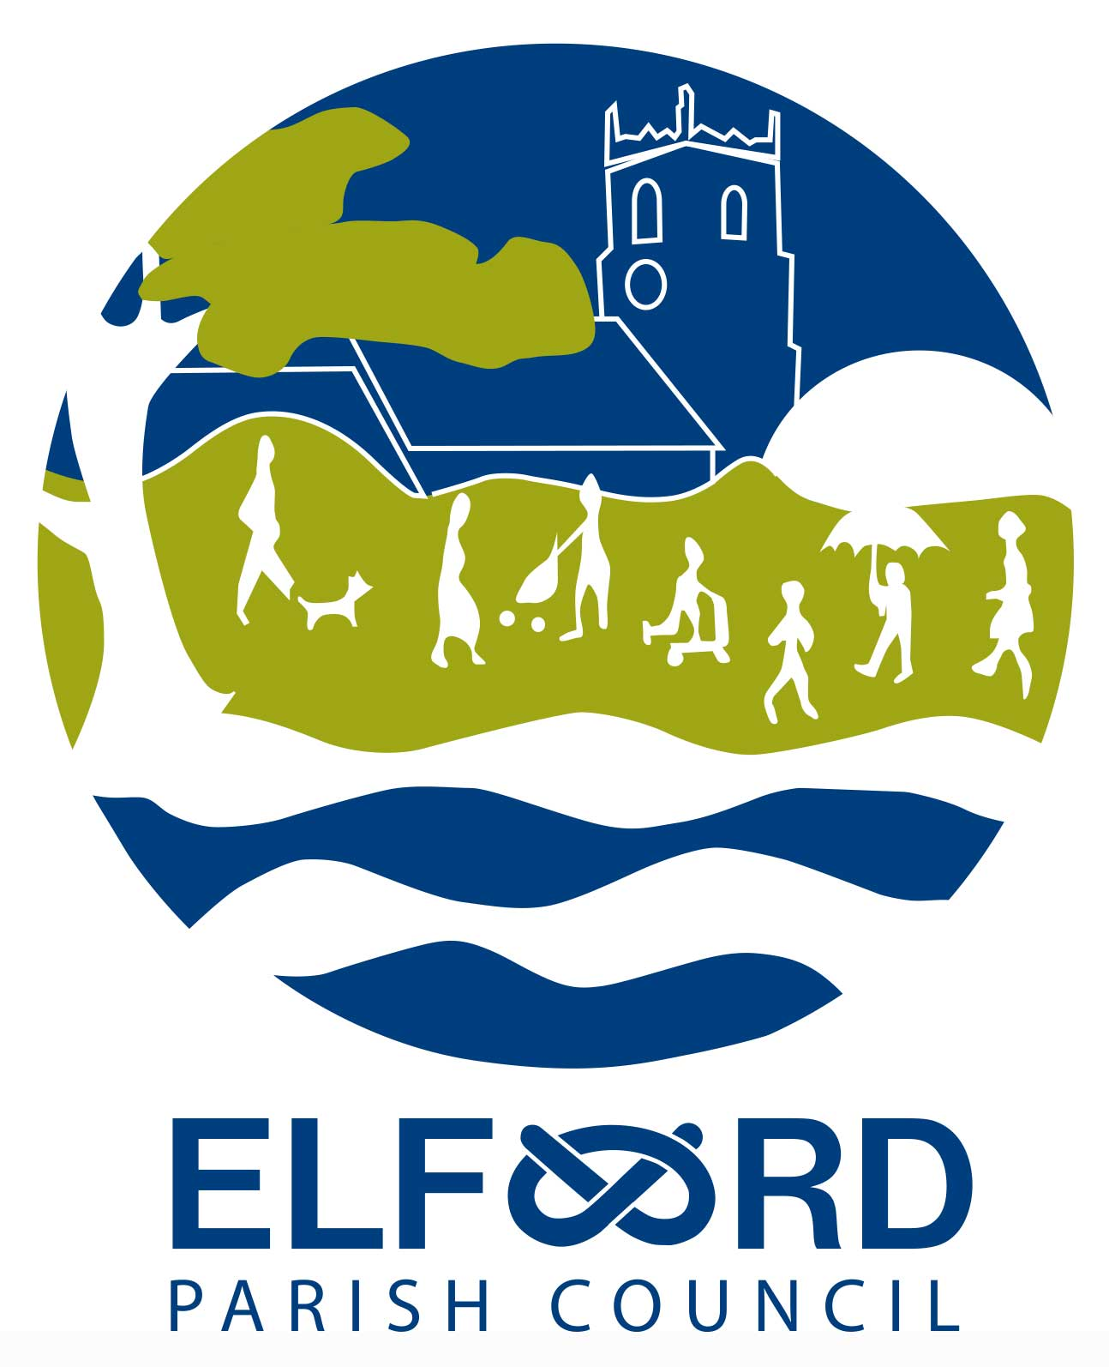 Meeting of the Parish Council

Monday 10th June 2019, 7 pm at Elford Village Hall

A G E N D A

Open Forum – public session 7 – 7.30

- To receive apologies for absence

- To receive Declarations of Interest

- To approve the Minutes of the meeting of 14/5/19

- To co-opt a member to fill a vacancy on the Parish Council

- To receive the Clerk’s report

- To consider any planning matters

- To consider Scarecrow Festival

- To consider donation from the Coffee Shop

- To consider Right of Way off The Beck

- To approve the Annual Governance Statement

- To approve the Accounting Statements

- To certify the Parish Council is exempt from a limited assurance review

- To approve the Internal Auditor’s report and appoint an auditor for the next year

- To consider maintenance

- To consider repairs to the notice board

- To receive questions and reports from Councillors

- To receive correspondence

- To receive a financial report

- To consider authorising schedule of accounts for payment

- Date of next meeting (Monday 8th July 2019)

