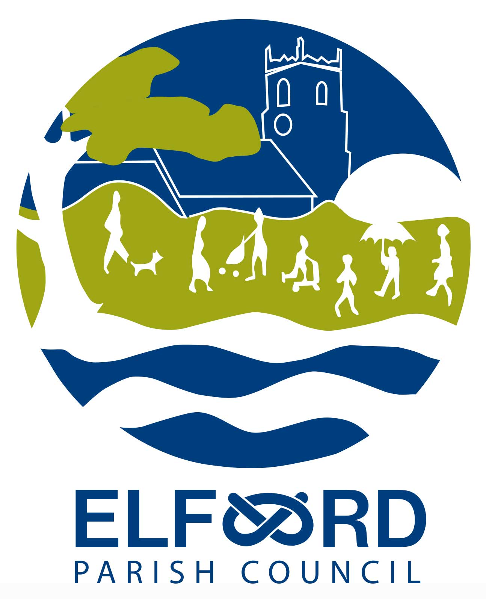 Meeting of the Parish Council

Monday 8th November 2021, 7 pm, at Elford Village Hall

A G E N D A

7-7.30 Open Forum – to receive any questions or comments from residents.

To receive Apologies for absence

To receive Declarations of Interest

To approve the Minutes of the Meeting of 12th October 2021

To receive the Clerk’s Report

To consider any Planning Matters:

Applications

Update on the Social Club site

To receive an update on development of land at The Shrubbery

To consider Playground Maintenance and Funding

To consider the Sportsfield

To consider traffic

- To consider an event to mark HM The Queen’s Platinum Jubilee

- To consider Forward Planning

- To receive Questions and Reports from Councillors

- To receive Correspondence

- To receive a Financial Report

- To consider authorising Schedule of Accounts for payment

- Date of Next Meeting : Monday 13th December at 7pm, Elford Village Hall

